WERRIBEE & DISTRICT COLLECTABLE VEHICLE CLUB (Inc.) (W.D.C.V.C.)
Postal Address: PO Box 841 Werribee 3030
E-Mail: wdcvc@hotmail.com
Inc. Reg No. A0024084P (ABN 575 840 445 12)
APPLICATION FOR MEMBERSHIP (FULL or ASSOCIATE)
Effective from 1st July 2020 / 30th June 2021
PROPOSED NEW MEMBER
*(Print) SURNAME: | Title:
*(Print) First Name: | Nickname: (if applicable):
Occupation: | Email address:
*Residential Address:
 |  |  | P/Code
Home Phone: Work Phone: Mobile:
SPOUSE/PARTNER (if applicable)
(Print) SURNAME: | Title:
First Name: | Email address:
Residential Address:
 |  |  | P/Code
For Administration Use Only
Date Received: |  | Date Checked:
Receipt: |  | Club Card Issued:

Age Group: Under 30 31 – 45 46 – 60 60 +
* Tee Shirt Size (S), (M), (L), (XL)
*Required Data
Do you intend to apply for Club Vehicle Permit Scheme for your vehicle/s Circle YES or NO?
There are a number of eligible criteria for Club Vehicle Permit Scheme – If you are unsure whether or not your car will meet these criteria, it is a good idea to check BEFORE you pay your membership fees. Information on Club Vehicle Permit Scheme can be found on page 4 of this document or contact our committee if you have questions regarding Club Vehicle Permit Scheme.
Please note if the vehicle registered in more than one name, all persons named on registration form must be Club Members.
PROPOSED BY (Print Name) | SIGNATURE | DATE
SECONDED BY (Print Name) | SIGNATURE | DATE
Accepted (Office Use Only) | SIGNATURE | DATE

Vehicles currently owned, either on the road or current project: (If you require more lines please attached list of your vehicles to application)
State of Restoration:
Year | Make | Model | Body Type | Colour | Registration No. | Engine No.
Membership Fees: For the 2020 – 2021 Year (1st July to 30th June)
Renewal Payment Due Date is by 30th June each Year if payment received after due date (30th June) late payment cost is $70.00.
Joining Membership Pack (Compulsory) $65.00.
Tick Box below for FULL or ASSOCIATE Member – incl. Email Monthly Newsletter.
- FULL Membership ASSOCIATE Membership
Fee $60.00 Fee $50.00
Membership pack $65.00 Membership Pack $65.00
TOTAL $125.00 $115.00
Cash Cheque Money Order
W.D.C.V.C Banking Details:
BANK: CUA (or Aust Post displaying “Bank@Post”)
BSB No: 814282
A/c No: 10495827
(For Direct Deposits): A/C Name: Werribee & District Collectable Vehicle Club
(We have been advised by the Auditor that you will need to send an E-Mail to the Clubs E-Mail address (WDCVC@hotmail.com) verifying your payment and description as sometimes the bank deposit does not allow much room to put your payment description. Also, your Bank Name may be different to what is shown on our records and your payment could get lost in the system.) IMPORTANT: Please quote your Name or Club Membership Number as Reference
Member’s Signature: Dated: / /20
NOTICE:
(1) The Office of Fair Trading has made it a legal requirement to advise you that the Club has Public Liability Insurance for General Products and Sub-Limits in Property in Physical and Legal Control.
(2) By Signing this Form, the Applicant agrees to the use of the Applicant’s Personal information for the purpose of Management and Administration of the Werribee & District Collectable Vehicle Club (Inc.) in Accordance with the Privacy Act 1988.
I ___________________________ hereby give the Werribee & District Collectable Vehicle Club authority to publish my contact phone numbers and e-mail address to fellow Members of the Werribee and District Collectable Vehicle Club. Use any personal information you chose to provide only for the purpose for which it was provided and will not be disclosed to other persons or organizations without your prior consent.

W.D.C.V.C. General Meetings held on the 4th Wednesday of each month at 7:30 PM
Club Room Located in New Mossfiel Pavilion located at (Mossfiel Reserve).
Enter carpark at roundabout on corner of Mossfiel Drive and Branton Road Hoppers Crossing 3029.
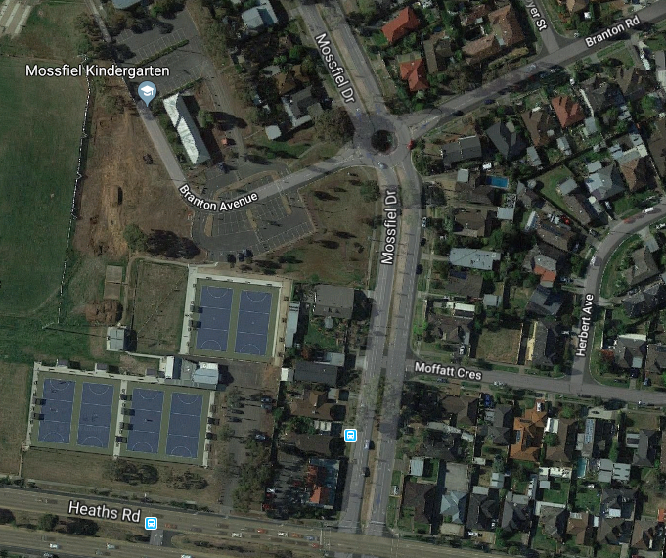
WDCVC Club Rooms

Werribee & District Collectable Vehicle Club (WDCVC)
Guidelines for applying for Club Permit Scheme.
The Club Permit Scheme (CPS) recognised by VicRoads to allow limited use of historic vehicles on Australian road network. This scheme allows 25+ year old cars, trucks, motorhomes or bikes to be driven under logbook rules that provide for 45 or 90 days per year use.
The scheme is popular because it provides lower total annual cost for permit and vehicle insurance when compared to normal registration and insurance.
Please refer to VicRoads website (www.vicroads.vic.gov.au) for general information about this scheme.
Our Club is authorised by VicRoads to operate under this scheme. There are responsibilities and obligations to VicRoads for both the permit holder and the Club.
Following guidelines are to assist intending CPS applicants to understand process. (Based on latest implemented VicRoads CPS requirements commencing 31st January 2015)
- You must be a (W.D.C.V.C.) FULL member and be financial before you can apply for a Club Permit. Associate members are unable to apply for CPS registration unless they move across to FULL membership.
- You must be a financial club member for a minimum of 1 month before being eligible to apply for a club CPS permit and continue to attend at least two (3) club events and or meetings each year in accordance with club’s By-Laws.
- You must retain your Club membership for duration of holding your Club Permit under WDCVC. Our Club has a process to notify VicRoads when a member who has a CPS vehicle is no longer financial. Your car will be legally unregistered if you are not a financial member of Club that signed off on your Permit even if you have paid VicRoads CPS fee.
- At least one W.D.C.V.C committee authorised to sign VicRoads forms must view vehicle before Club signs VicRoads eligibility form.
- For a vehicle to be eligible, an Australia vehicle Compliance Plate must show that vehicle is 25 years or older at time of application for Club Permit Registration.
- Application for a VicRoads CPS Plate must be accompanied with Proof of Ownership or Management of Vehicle document; this can be provided in the form of Original Receipt or Contract of Sale. The document to include VIN or Chassis Number, Engine Number, Name, Address and Signature of Previous Owner, Name and Address of New Owner and Date of Transaction.
- A completed Vehicle Eligibility and Standards Declaration Form approved by one of the Club’s Safety Officers’ must accompany application for CPS Plate.
- Download complete set of (2) Club Permit Application forms found on VIC Roads Web site www.vicroads.vic.gov.au.
- If car/motorcycle is a Historic Vehicle and not a Street Rod and manufactured after December 31st 1948 then a certificate of roadworthiness is required. If the vehicle was manufactured prior to 1st January 1949 a signed Safety Report from one of our two (2) VicRoads authorised officers is required.
- In the case an application is made in respect of a Street Rod, “That is a vehicle modified” in excess of the level prescribed in the Vehicle Standards Information No.8. (VSI8) document [PDF, 279 KB, 8pp.], a Street Rod Inspection certificate issued by any VASS Signatory [DOC. 1113KB, 7pp] authorized to undertake street rod inspections must be presented.
- After meeting our Club’s waiting period a Member applying for Club Permit Scheme Plates must bring to meeting, minimum 5 images (Can be in electronic format)n dated and signed (Front, Side, Rear, Interior and Engine) of vehicle for WDCVC club records. A passed Victorian certified roadworthiness certificate, or signed Safety report from one of the Club Safety Officers. Member to bring to club general meeting all completed documentation required by VicRoads with photos and completed VicRoads Club Permit Scheme application forms, for signing by Club President/Secretary all documents then copied for Club records.

